Amr Darwish

Contact information
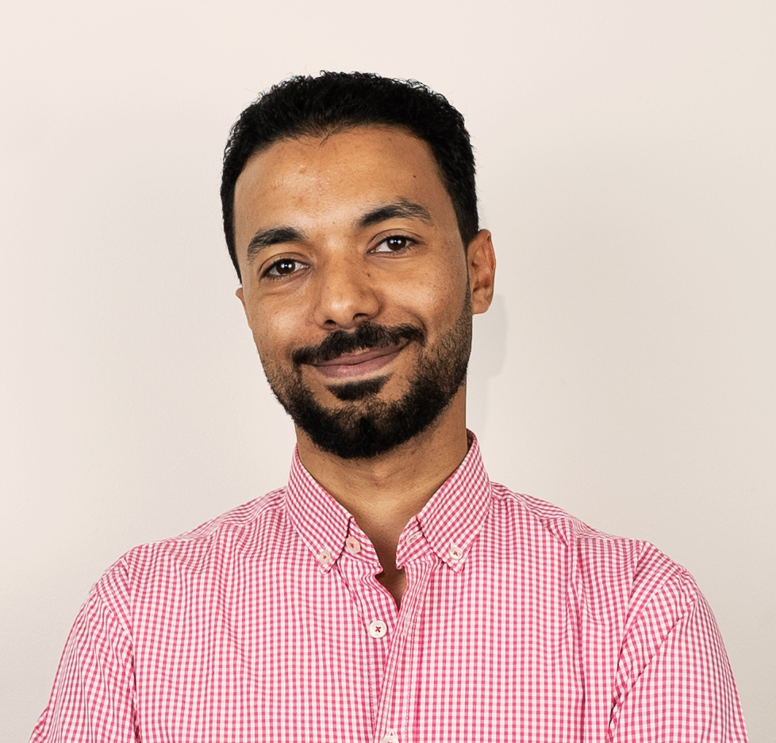
- Mobile Phone: +201015817851
- Home phone: +20882036060
- Email: amrdarwish@aun.edu.eg
- Address: 468, Businessmen District, New Assiut city, Assiut, Egypt, 71515
Professional Summary
A well-trained specialist in urology offering vast experience in various urological procedures, excellent interpersonal communication skills and thorough medical knowledge in addition to outstanding research skills.
Personal information
- Passport No.: A09716270
- National ID No.: 28905162500111
- First name: Amr
- Middle names: Esam Saad
- Last (family) name: Mohamed
- Gender: Male
- Date of birth: 16/05/1989
- Country of birth: Egypt
- Nationality: Egyptian
- Marital status: Married
- Military service: Completed at Urology, Nephrology and Liver and Renal Transplant center, El-Maadi Armed Forces Hospital, Cairo, Egypt
- Languages: Arabic (mother tongue), English (excellent)
Education
2006 High school diploma (basic education), New Salam School, Assiut, Egypt
2012 Bachelor of Medicine and Surgery (M.B.B.ch), Faculty of Medicine - Assiut University, Egypt, Excellent with honor degree
Post-graduate qualifications
Oct 2018 Master of Science (M.Sc.) in Urology, Faculty of Medicine, Assiut University, Egypt, a "Very good" grade
Clinical Skills
- Patient evaluation and management  - Stepwise approach of decision-making  - Accurate clinical judgment  - Up-to-date management protocols  - Pre- and post-surgical care  - Minimally invasive procedures: ESWL | - Most of endoscopic and open urological procedures and, to less extent, Laparoscopic procedures  - Diagnostic procedures: Ultrasound and Urodynamics
- Excellent computer skills: Windows, Microsoft Office, Internet, IPSS | - Teaching skills  - Presentation skills
Other skills

Work History
Nov 2020 – Aug 2021 | Urologist at Urology Department, Alexandria Main University Hospital and Alexandria Urology Hospital (AUH), Alexandria, Egypt
Nov 2018 - Current | Assistant lecturer (specialist) of Urology - Assiut Urology and Nephrology Hospital, Assiut University Hospital, Assiut, Egypt
Sep 2016 – Nov 2018 | Demonstrator of Urology - Assiut Urology and Nephrology Hospital, Assiut University Hospital, Assiut, Egypt
Dec 2014 – Dec 2015 | Urologist at the Urology, Nephrology and Liver and Renal Transplant center, El-Maadi Armed Forces Hospital, Cairo, Egypt
Mar 2014 – Sep 2016 | Resident of Urology - Assiut Urology and Nephrology Hospital, Assiut University Hospital, Assiut, Egypt
Mar 2013 - Mar 2014 | House Officer - Assiut University Hospitals, Assiut, Egypt
Work activities
- Closely monitors admitted patients and manages of their therapy plan.
- Provides on-call care at all times of day and night.
- Instructs patients and family members on proper discharge care.
- Records history and performs examination for patients presented at urology outpatient clinic
- Provides patient education and advises patients on different treatment plans.
- Have Performed and assisted in different urological open, endoscopic and laparoscopic urologic operations and also minimally invasive procedures such as ESWL and Urodynamics.
- Have maintained good communication between department heads, medical staff and governing boards by attending board meetings and synchronizing interdepartmental functions.
- Have partnered with several teams of registered nurses to achieve overall well-being of all patients.
- Coordinates with other internal departments and customers to keep operations running smoothly and solve both routine and complex problems.
- provides postoperative care such as wound dressing, drain removal, requesting labs and imaging, monitoring vital signs and Urine output and description of medications
- Closely monitored acute conditions and manages critical cases.
Teaching and supervision activities
- Conducts monthly patient case conferences, in-services and staff meetings to educate staff and facilitate good communication.
- Educates junior residents and house officers how to deal with different urological cases
- Teaches under-graduates
- Have been tutoring OET since February 2019
Publications
Feb 2019 First author of a paper titled: "Outcomes of ureteroscopy in Assiut University Hospital: A prospective study" – DOI: 10.4103/JCMRP.JCMRP_100_18
July-Sep 2019 First Author of a paper titled “Ureteral stricture after ureteroscopy for stones: A prospective study for the incidence and risk factors” – DOI: 10.4103/UA.UA_110_18
Membership
- A member of the Egyptian Urology Association (EUA) since 3/2018
- A member of the American Urology Association (AUA) since 02/2019 – ID: 01027697
Workshops and Training activities and certifications
May 2013 | Surgical suturing
May 2013 | Infection control
Sep 2013 | Ethical, law and administrative consideration in medical practice – Assiut, Egypt
Sep 2013 | Cardiopulmonary resuscitation (basic course)
Jun 2016 | Ureteroscopy teaching course (flexible and semirigid URS) – Cairo, Egypt
Mar 2017 | Laparoscopy workshop
Sep 2017 | Flexible ureteroscopy and semirigid ureteroscopy teaching course and workshop – Cairo, Egypt
Nov 2017 | International training course in scientific writing and publications - Assiut, Egypt
Dec 2017 | International reconstructive Urology workshop – Assiut, Egypt
Mar 2018 | Endourology scientific meeting and work shop
Mar 2018 | Advanced Cardiovascular Life Support (ACLS – Operation Smile)
Aug 2018 | Uro-oncology scientific meeting and work shop
Oct 2018 | Statistical analysis
Feb 2019 | Endourology Workshop – f.URS, An Update (Assiut Urology Hospital)
Sep 2019 | American Board Review Course
Sep 2021 | Flexible Ureteroscopy (Uroalex 2021)
Oct 2021 | ESU/ESUT Hands-on Training Laparoscopy course (MMISU)
Nov 2021 | EUA-AUA course in Urology
Dec 2021 | Advanced uro-Laparoscopy course (MMISU)
Jan 2022 | UroPro annua scientific meeting
Feb 2022 | Basic Uro-Laparoscopy course (MMISU)
Mar 2022 | EUA Andrology meeting
Jul 2022 | International Gastrointestinal Liver & Uro-oncology 11th annual meeting
Dec 2022 | EUA 26th annual conference

